Google “Ernie”

It will take you to Embry-Riddle Login

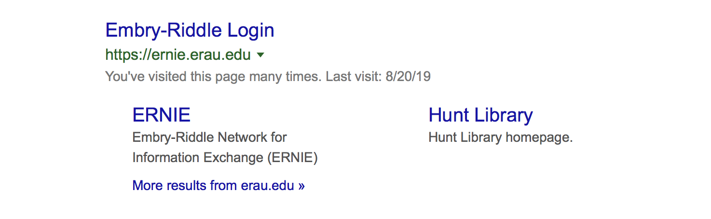
LOGIN

marta114

myname1234***

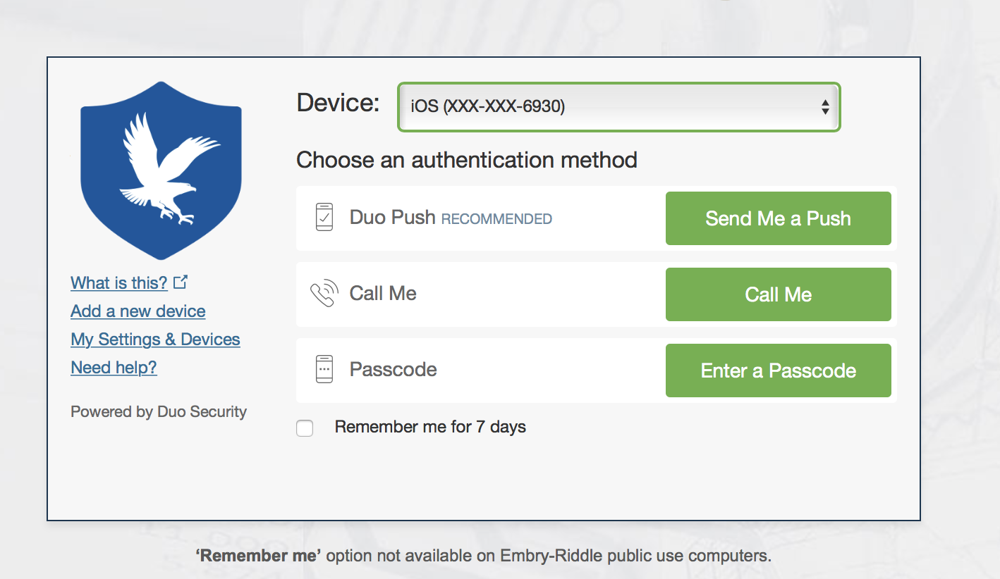

Chose Device: ISO (XXX-6930) ***Important

THEN: DUO PUSH - Press “SEND ME A PUSH”

It will contact my phone, and I will let you in.

Where to Find Assignments/Quiz:

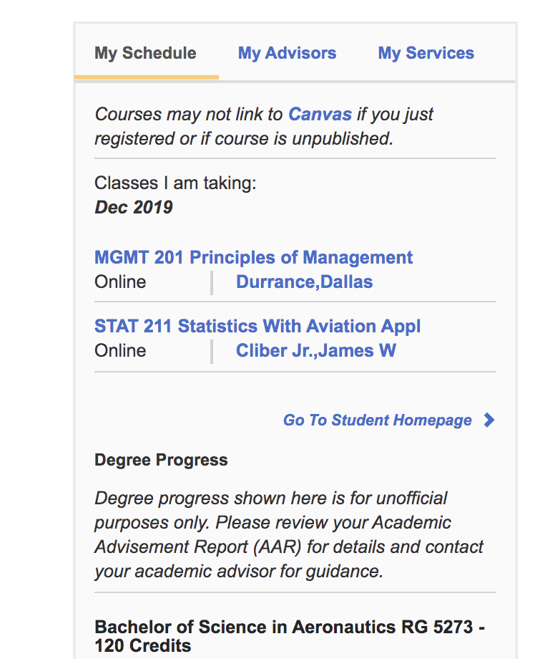

Chose: STAT 211 Statistics with Aviation Applications

Chose Grades:

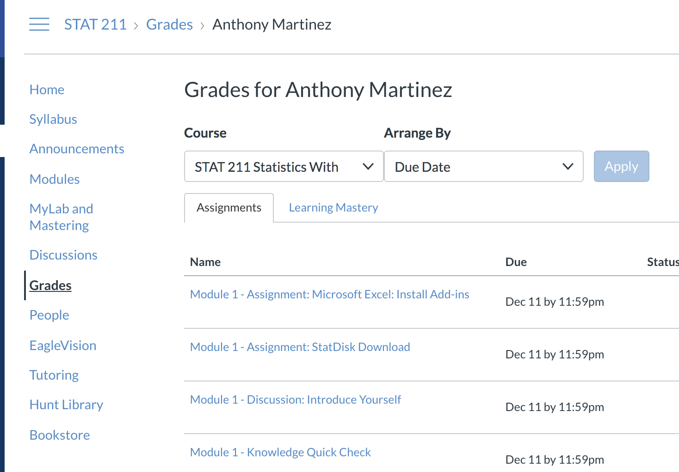

Then Chose: Module 1 Homework: Textbook Chapter 1

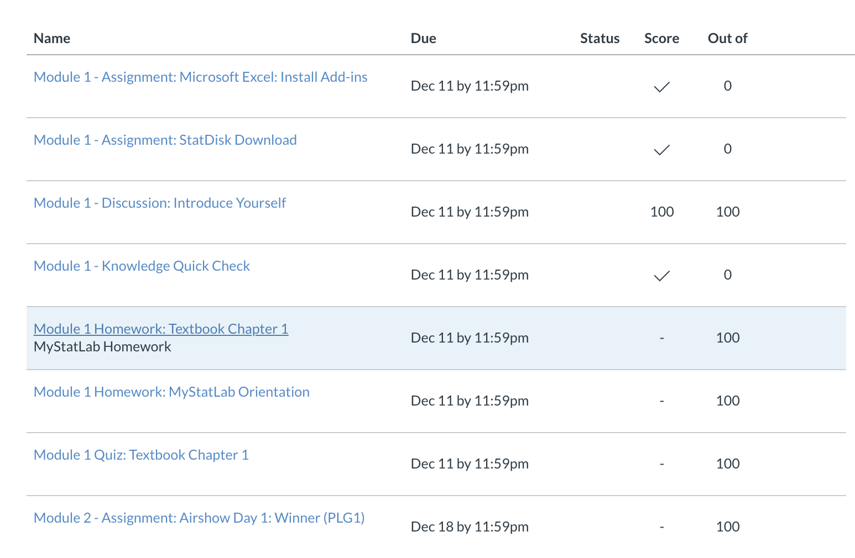
Remember if you have an account with Chegg.com. or CourseHero.com, it helps with some questions. Maybe Even with the Quiz (I know it helped a lot in other business classes.)

**Then: Scroll to the top - Module 1 Homework: Textbook Chapter 1

**Same when your ready for Quiz

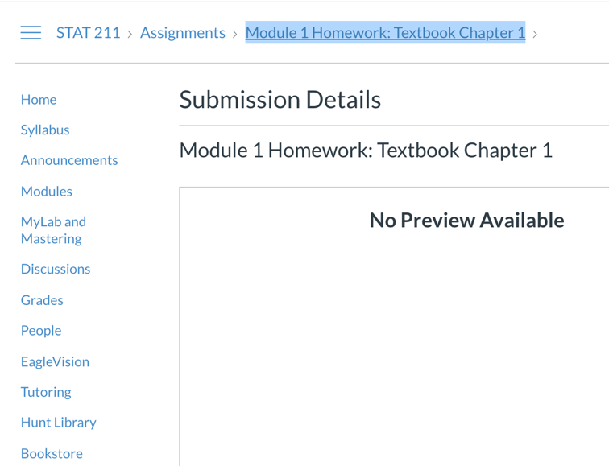

When you’re ready for Quiz

Chose: Module 1 Quiz: Textbook Chapter 1

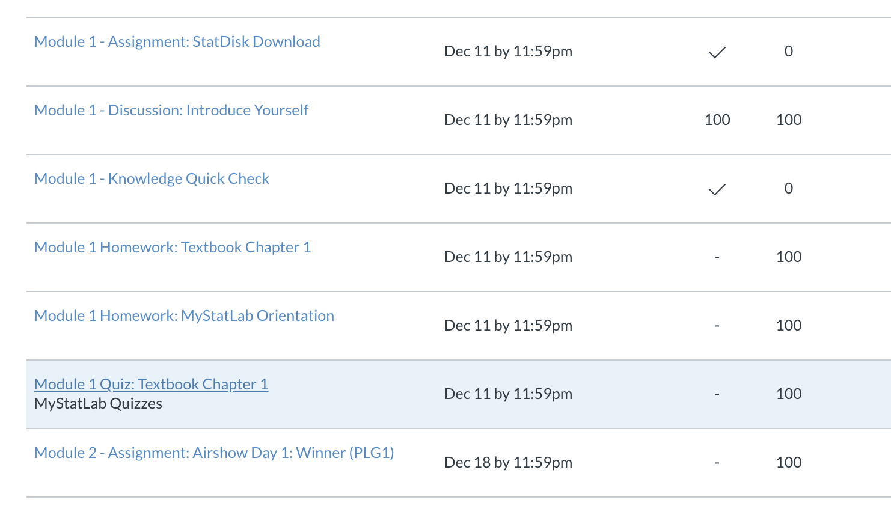

You have 2 attempts for quiz: Good luck, and Thanks a lot!!

